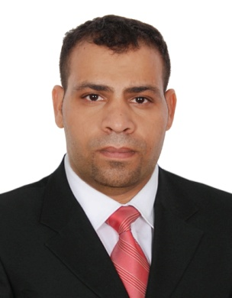Hassan Ali Mohamed Alrashed

**Cell:** +973-39053332

**Email:** Hassanskyline0@gmail.com

|  |  |  |  |
| --- | --- | --- | --- |
| **OBJECTIVES** | | | |
|  | | | |
| * Experienced heavy driver seeking position with a reputable logistics company. | | | |
|  | | | |
| **PERSONAL DATA** | |
| **Nationality:** | Bahraini |
| **Marital status:** | Married |
| **Date of Birth:** | 31/10/1984 |
| **Address**: | House 237, Road 2209  Block 1022, Dumistan–Kingdom of Bahrain |
| **Contact Number:** | Cell: +97339053332 |
| **E-mail:** | Hassanskyline0@gmail.com |

|  |  |  |  |
| --- | --- | --- | --- |
| **EDUCATION** | | | |
| * Al Khalil Bin Ahmed Intermediate Boys School | | **1997-1998** |
| **EXPERIENCE** | | | |
| **Heavy driver** | **31 October 2014 to 16 April 2019** | | |
| **Kingdom Company**   * Drive mixer truck on public roadways in accordance with company safety policies and traffic laws. * Drive mixer truck in product loading and unloading. * Conduct regular vehicle inspections and inform maintenance department of any problems. * Shoulder the responsibility of maintaining the mixer truck in a clean and safe operating condition. | | | |
|  |  | | |
| **SKILLS** | | | |
| * Excellent driving skills and ability to perform physically demanding tasks. * Ability to work well under pressure. * High level of commitment and initiation toward work. | | | |

|  |
| --- |
| **REFRENCES** |
| Available upon request |